ANNUAL REPORT 2021-2022

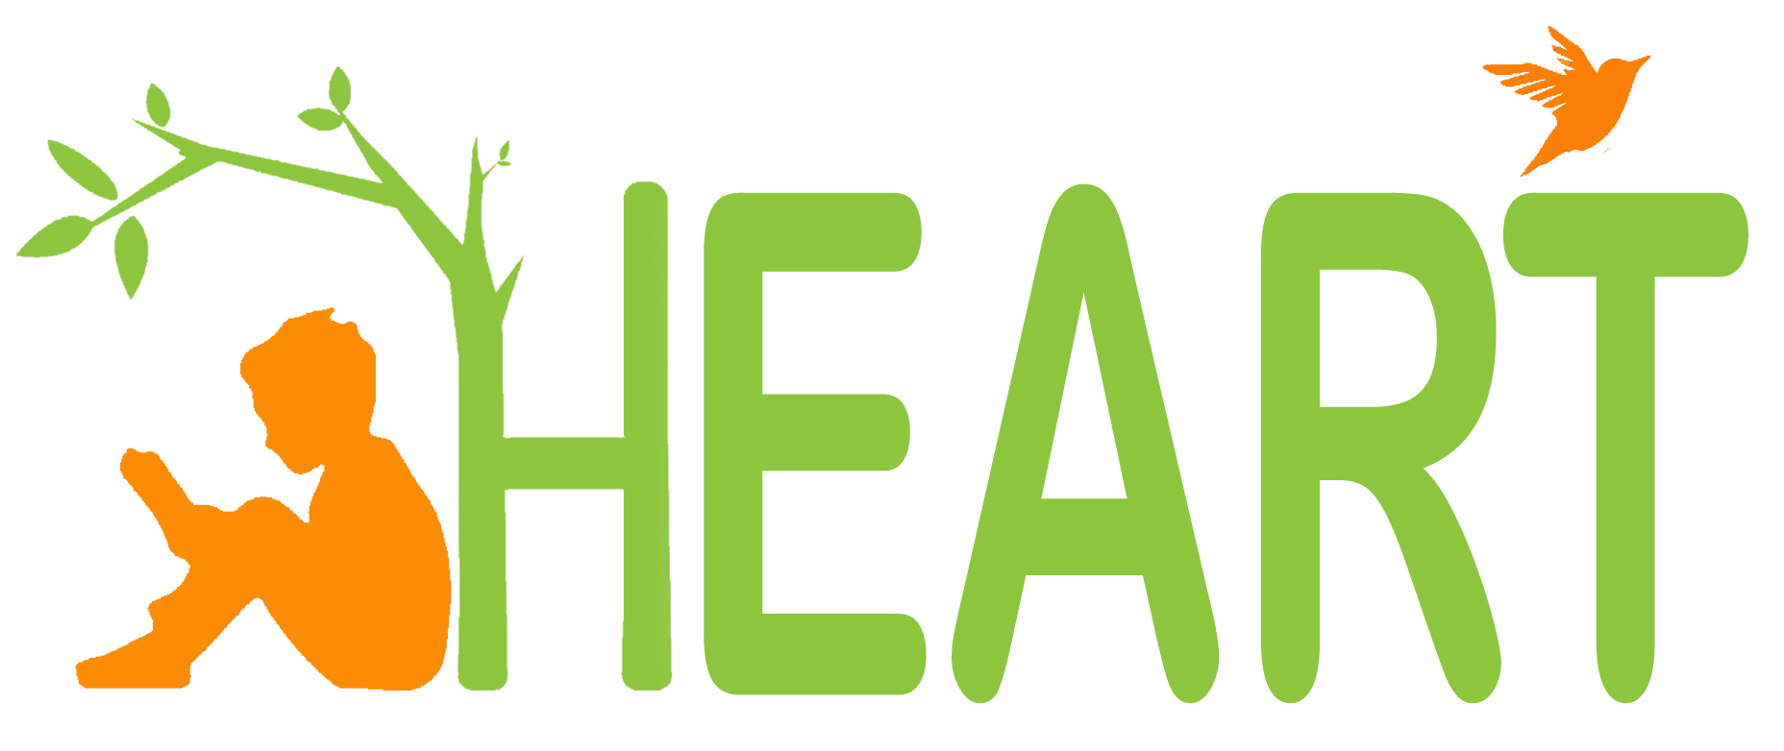

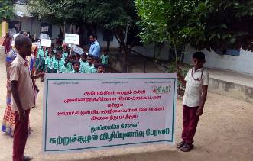
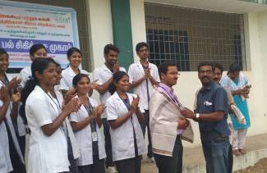

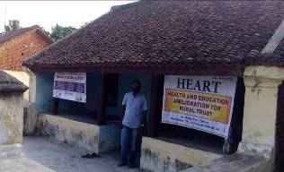
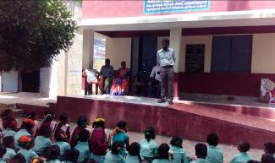

HEALTH AND EDUCATION AMELIORATION FOR RURAL TRUST

(Registered under Indian Trust Registration Act 1882)
No.19, Big Street, Padalam, Madurantakam Tk, Kanchipuram Dist – 603 308.
Email Id : hearttrust1@gmail.com Contact No : +91 - 9790518703
(Registered under the Income Tax Exemption act 12AA & 80G)

HEALTH AND EDUCATION AMELIORATION FOR RURAL TRUST

No.19, Big Street, Padalam, Madurantakam Tk, Kanchipuram Dist – 603 308.

ANNUAL REPORT 2021-2022

INTRODUCTION:

Health and Education Amelioration for Rural Trust was established in 2017 with a group of committed Womens in the field of rural development. “HEART” got its legal entity by registering under the Indian Trust Registration Act 27 of 1975 with a registration number of 40/2017 on 07.11.2017. “HEART” is also registered under the Income Tax Exemption act 12AA & 80G. “HEART” started its activities in the remote rural areas of Chengalpattu District with its awareness campaign, Skill Training, Micro Finance, Environment Programme, Health and Educational Programme. The first one decade (2017 - 2019) was fully concentrated on Environment, Health and Educational awareness raising and community mobilization activities.

In the next one decade (2019 – 2022), “HEART” emerged as one of the leading organizations in the field of Educational, health and economic empowerment of the target communities through women self-help groups’ formation and training.

VISION

“HEART” envisions a society wherein all people will have equal rights and access to protected Educational, health and Environment improved income status without gender discrimination.
MISSION

“HEART” will function as an NGO for promoting overall improvement of the rural, urban, coastal and tribal population in India thus working for the empowerment of the target communities especially the women, children and the marginalized sector.
What we are doing?
- Women SHG Programme
- Women & Child Care Programme
- Environment & Forest Programme
- Income Generation & Skill Training Programme
- Free Legal Programme
- Yoga & Meditation Programme
- Organic Farming Camp
- Handicapped Welfare Programme
- Consumer Awareness Programme
- Old age Persons Welfare Programme
- Animal Welfare Programme
- Medical Camp
- Road Safety Programme
- Free Tuition Centre

WOMEN SHG PROGRAMME :-
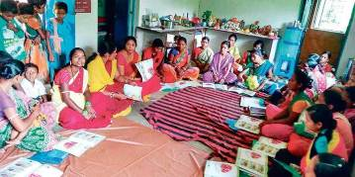
S.H.G. Awareness programme
The internalization of the social development process largely relies on the collective cohesive dynamism of the disadvantaged and conducts regular meetings in organizing them under SHG structures. Through which they could learn savings, finance management, literacy and numerical, skill development, credit access and income generation. The program was focused at Padalam village and women communities were mobilized and sensitized on the need of group dynamism the key factor in the women development. Mr.Pandian.K facilitated the meetings and sensitized the communities on the SHG structure promotion.

World women’s day programme
“HEART” observes the World Women’s Day on March 8th of each year with women SHG’s and federation participation. In this connection public meeting, rally, seminar and street theatre programme were organized.

WOMEN & CHILD CARE PROGRAMME :-

Women and Child Right Advocacy program
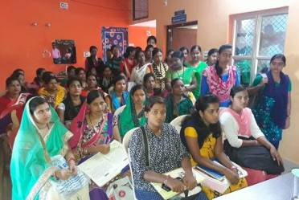
The government's report reveals that 41,599 girls are working as 'camp coolies' in Chennai district, 7,810 in Kanchipuram and 9,052 in Tambaram. The context should draw international development service providers moral inclination as in an emergency response situation and collectively took solidarity stand against the women right violation incidences in Tamil Nadu. Tamil Nadu government has recently passed a bill to stop this notorious system. But the recruitment continues and all kinds of violation incidences continue.

“HEART” wishes to address this imperative issue and need on the rehabilitation of the affected adolescent girl children and young women victims in effecting liberation of women in Toto from the influence of false promises and ensure true social justice and equity through women empowerment. For which organized a sensitization meeting involving right activists, line departments, “HEART” and women leaders and the program have reached around 500 general public.

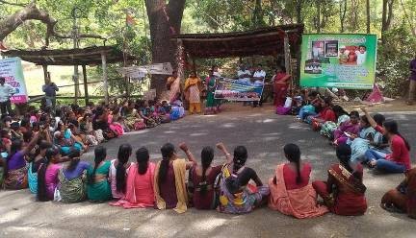
Child rehabilitation awareness programme
Through this program appropriate awareness is being generated across the communities on the need of mainstreaming the children in trafficking, children in labor, children dropouts in regular schools and rehabilitation of their mothers to develop a child a valuable responsible citizen of the country. Our NGO sponsored and organized a program in Govt Special School and distributed quality food, and clothing to the inmates. The Principal of the Institute participated in the program and invited other stakeholders to participate in a program.

With the support of the SSA child dropouts’ program survey and identification were conducted on the whole of Acharapakkam Block. We have identified 66 children dropouts and registered in the listing of SSA and the Chairman presided the function.

Breast Feeding Awareness Programme
The pre, peri and post-natal mothers were identified and given awareness on the advantages of breast feeding. The mothers were sensitized on the nutritive diets preparation and supplementation.

FREE LEGAL PROGRAMME:-

On Thursday 21st September, 2021 our NGO organized a legal aid camp in the village of Bukkathurai (Tamilnadu). 3 Village People and College Student participated.

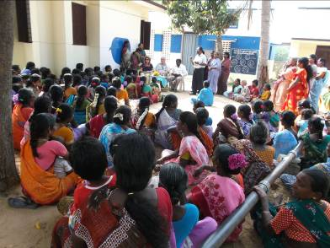
People briefed them about various topics such as Consumer awareness, Right to information, FIR (First Information Report), Right of a person detained in the custody, Free Legal aid, Beti Bachao Beti Padhao, Dowry, Swacch Bharat Abhiyan, Lok Adalat, Rights of Women and children, Child Marriage, Sukanya Samridhi Yojana , Right to Education , female feticide, Importance of girl child and some various other topics related to their daily lives. Villagers including farmers, business men, young boys, women, Children and old people, all have participated and they also interacted with the students. Meanwhile some of the villagers asked various questions regarding their rights and duties. Some of them also shared their problems which they facing professionally and asked for the solutions from the students, students answered them in a brief way and told them every actual possible way to solve their problems. Some of the students distributed some forms as well like, how we can avail the Free legal aid and what is the actual procedure of availing it .It was a very well conducted program.

Students tried to help them legally in every possible way. They even invited students again to visit their village and want more legal aid camps like this in the future so that they can get the maximum benefits.

Family counseling programme

In any Indian family environment with low income profile the conflicts of opinion is common between the male and his counterpart. To ease the stress the program helps in bringing harmony and peace through counseling and rehabilitation services.

Human right awareness programme

Poverty and human right violations are closely related components often needs to be answerable through awareness generation at the first level of internalizing the activism. The communities were assisted with legal aids and legal awareness. The program suppresses in the incidences of child right and women right violations common among the unmet communities.

ENVIRONMENT & FOREST PROGRAMME:-
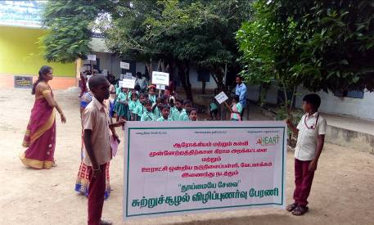
School And College students were taken as change agents in the sensitization of natural environment awareness. The participants visited various places of importance on biodiversity, flora and fauna and degraded environment and adaptable restoration practices through tree plantation.

Segregation of solid waste disposals plays an important role in the preservation of underwater and surface pollution. For this sensitization meetings and demonstration were organized to segregate the waste as decomposable and non-decomposable and further insists on the general public on the use of decomposable packaging materials, paper cups and be in part of the conservation of the fragile ecosystem.

The program was organized and well coordinated by the “HEART” at Govt. Middle School at Vedavakkam Village, Madurantakam Tk, Kanchipuram Dist.

The organized rally insisted upon the ban on use of plastics, precious water resource conservation management, rainwater harvest, and eco-friendly lifestyles and energy efficiency.

In the context of climate change mitigation measures around 500 tree saplings were raised and planted in the Panchayth area of Andavakkam.

Global warming and climate change effects affects the poorest of the poor at the poor social groups. The government machinery still not got prepared for the mitigation measures it is the imperative of the environment activists to sensitize the grassroots in the adaptation of the appropriate technologies that would reduce the carbon footprints and minimize greenhouse gas emissions.

In considering the facts “HEART” has organized a fact finding across the Thirisoolam on the forest resource degradation, tree felling and tourist ambient pollution in the fragile ecosystems. After the study the results were reported to the line departments and sensitized the grassroots in organized meetings at village levels and hamlets in deep forest fringes.

- Destruction in large levels in Thirisoolam forest zone without the awareness of the indigenous communities
- Deforestation by using the indigenous communities unknowingly on meager wages
- Middle men exploitation of the indigenous communities on the trafficking of medicinal and aromatic plants.
- Large areas of the plateau have been planted with exotic 'commercial' mono-cultures consisting of species such as eucalyptus, pine and wattle for pulp and tanning needs where in which the indigenous communities are bonded labors.
- Poor sustainable income of men in plantation and the new tourism industry as bonded labor and traffickers unknowingly.

SKILL TRAINING PROGRAMME:-

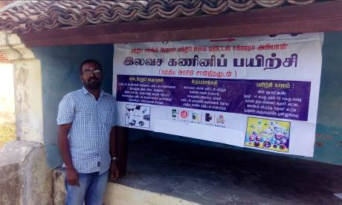
Several trainings were conducted in our Trust to upgrade quality based skill Training programme for the youth especially unemployed youth. The main objective of the programme id to train unemployed and underemployed youth with employable skill sets to start their own business. We have distributed the pamphlets to the nearest areas in order to mobilize the population. We have conducted the following skill Training under this programme They are :

• Computer Training
• Food processing Training
• Plumbing Training
• Paper cubs / plates making Training
• Tailoring Training
• Web designing

Computer Training:
This is a 3-months training programme for the selective 30-beneficiaries belongs to 10th passed and +2 passed female candidates in Padalam. In this programme M.S. Word and DTP trainings and hardware mechanisms are offered. Forenoon and afternoon session classes are conducted having 3 hours per class. In the training the scanning, printing and internet training are also given. On completion of the training certificates are issued to the successful candidates. The placement cell organizes campus interviews for self-employment and employment opportunities. Majority of the successful beneficiaries are placed in self-employment and employment positions.

This skill development is provided to selective 10 youths on a period of 3-months period. All the successful beneficiaries are placed in a decent salary in servicing centres in the local area.

They were also trained to use the updated educational software and latest knowledge about the particular training. Training were also organized to upgrade the hardware skills and MIS skills of the Computer. Women were given more important, they were trained under tailoring, call centre and food processing etc. We had tie up the local financial company to arrange group loan for the women The core objective of the trainings has been to teach how we self sustain to learn such kind of Training programme.

Tailoring training programme
The poor women could gain little income generation opportunities through the accomplishment of this particular skill. Chennai & Kanchipuram district hosts more numbers of Export Company which could siphon the contracts on dress making in their homes. The beneficiaries are selected from Padalam. 15-members belonging to Dalit classification got benefited in the program and got placed in meaningful employment and self-enterprising opportunities.

AIDS AWARENESS PROGRAMME:-
HIV/ AIDS Awareness Programme
“HEART” observes the World AIDS Day on December 1 of each year with students, general public, STD / HIV-AIDS affected persons, and conducted a rally starting from “HEART” office and ended in the Panchayath Office surrounding Padalam. This programme highlights the prevention of STD / HIV / AIDS. The population coverage reached a population of around of 2594 populations through IEC distribution.

HIV awareness on World AIDS day: “HEART” every year observes World AIDS day to reach common people with the message on HIV/AIDS and thus bring them also in the prevention mission. In this year “HEART” organized a rally with placards and message pamphlets on 1st December 2021 and at the end organized a public meeting briefing about HIV/AIDS and the prevention methods in Padalam Koot Road areas.

MID DAY MEALS TO ELDERS:-

“HEART” runs a Mid-day Meal initiative for the elderly poor women in Padalam NGO Office. These women have no family members, or abandoned by their families. They don’t have any financial support. They are not able to do any work. “HEART” is serving such women in need by providing them Mid-day Meals every day since 2021. Under this program, with our limited resources, we provide nutritious midday meals to 25 poor old people from nearby slums Area every day. Every day we have different menu for Mid-day Meal. Everyday a complete wholesome nutritious meal (including Egg, Banana & Sweet) is served. Individuals can contribute and donate to take up this cause and help us serve the elderly women in need.

MEDICAL CAMP:-

General medical camp programme
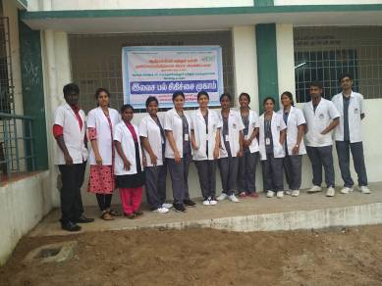
The general medical camps are organized with the support of the hospitals and healthcare professionals and utilizing the nursing and lab technician students on exposure at regular intervals in sensitive places. Other than the awareness generation on pandemic disease infections, cancer, TB, disability and vaccination needs of children screening is conducted on the various life killing illness and medically assessed for medical follow-ups.

SC / ST AWARENESS IN GOVERNMENT SCHEME:-

Tribal communities self-employment training program
This is a one month training programme. In this training for the household women to do their practice at their homes themselves Bleaching powder, ink, Phenol & Omam water, Candle, Washing Powder, Cleaning powder, head ache ointment, computer Sambirani, liquid blue, tooth powder, Appalam, vegetable pickles, milk Goa, Snacks, all cool drink mixes, shells, Sippi, Sangu, door curtains, garlands, photo garlands, decorative materials, ornamental products, fish pickle, crab pickle, prawn pickle, cutlets manufacture training.

On completion of this training for their business purpose they are selected through groups and the bank loans are arranged. Also they are trained to market their products.

SWACHH BHARAT PROGRAMME:-

In view of the environmental problems due to improper solid waste management in the country, the activities of the Campaign shall focus on the theme of this year. Emphasis should to given for devising concrete, action-oriented activates that serve as worthwhile solutions to the issue/ problem related to the Swachh Bharat and Local Schools & Government Buildings cleaning, The same be detailed out in the activity component in the proposal submitted to “HEART” by the Organising Agencies. The following is the indicative list for awareness and action components that may be organised for different target groups during the Campaign-

ACTIVITIES:

An indicative list of awareness activities that may be organised under NEAC include-
- Insightful workshops, public meetings and / or exhibitions on the relation between pollution, sanitation and health.
- Training programmes,
- Competitions, Quiz, demonstration on,
- Preparation and use of audio-visual materials besides CD-ROM and other multimedia tools,
- Camps, yatras, rallies etc,
- Folk media and street Theatre

Action component of the campaign to be taken up by the approved organisations shall be based on the theme of the campaign. A suggestive list of action components include:
- Cleaning of Streets, Roads, Ghats, Markets, Vegetable Markets, Fish and poultry
- markets etc.
- Composting, vermin-composting of bio-degradable waste.
- Installing bins for segregation of wastes.
- Recycling of waste.
- Providing alternative material to polybags.
- Inventorisation of Solid waste and its Characterisation.
- Documentation of local traditional knowledge/ practice related to permaculture, waste management, water conservation, weather forecasting etc. and its benefits.
- Planting native tress alongside of river banks.
- Practicing and encouraging water harvesting techniques, development of trenches, soak pits, conservation of local water bodies, small bunds etc.
- Providing and promoting carry bags made out of discarded/ old cloth or made of any other environment friendly material to discourage use of plastic and disposal in rivers as well as in drains.
- Providing Pitchers and other traditional healthy containers to contain water instead of plastic bottles.
- Making ground water reserves on river banks and nearby areas.
- Preparation and promotion of bio-pesticides, bio-fertilizers etc.

RURAL EDUCATIONAL PROGRAMME:-

Tuition And Spoken English Training :
Tuition programme was conducted for school going children at free of cost. Many of the children's parents are working more or less uneducated, so these were our target. Education to the children through 'Tuition and special spoken English based Learning Method which helps students learn faster. We have given chances for the educated women to handle these class, so that they were also get an employment opportunities.

Acknowledgement
We gratefully acknowledge the contributions of many in the activities of our organization. Our sincere thanks extended to all our friends and well wishers and supporters and because of them only we could able to travel further towards our vision.
- Public Health Departments at Block & Panchayat Levels.
- BDOS,
- District Administration and other agencies
- Local Union Administration & Village Panchayat Administration



